### Pretty Kitty Pop-Up Card

I love my kitties so I made a pop-up card for them.

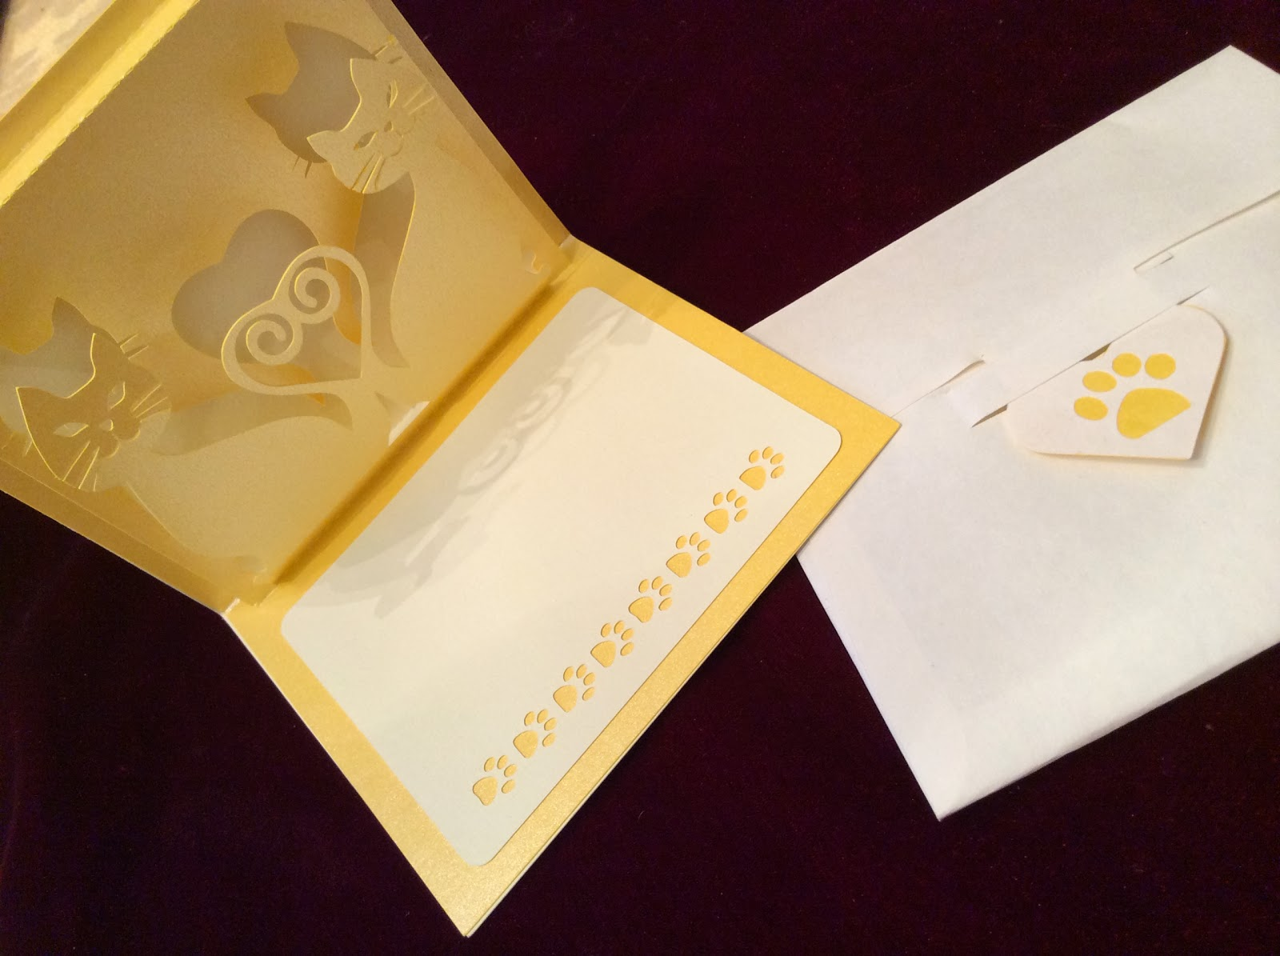

Pretty Kitty Pop-Up Card

I love my kitties. Here is the picture that inspired this card.

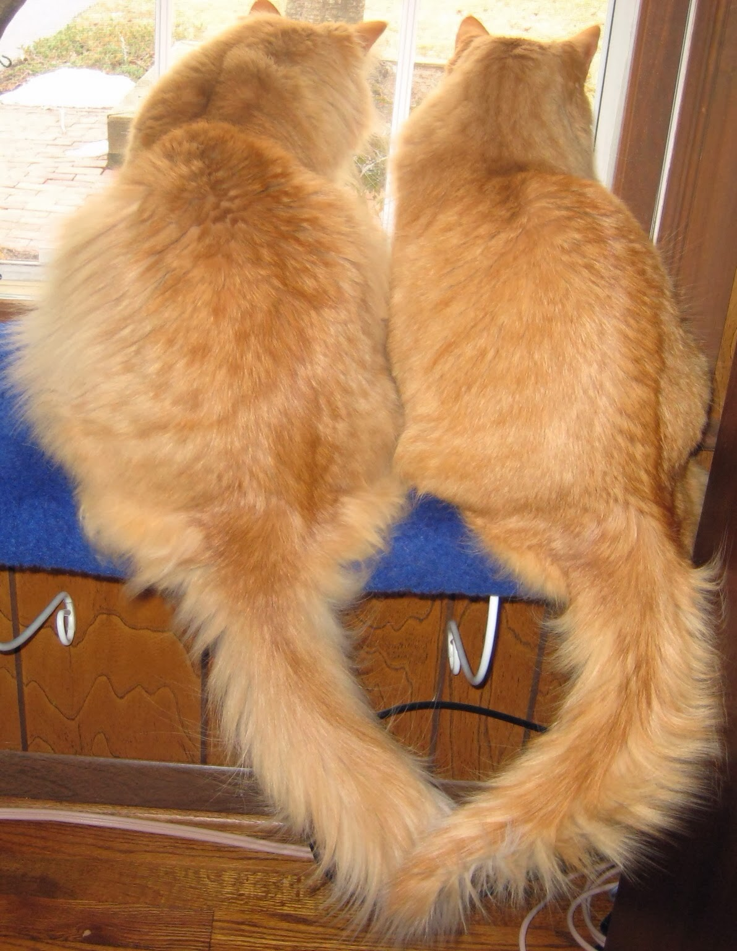

Marley and Melvin looking at their bird friends. I love the way that their tails are entwined.

It looks like a heart!